**3 tiers Architecture**

**Presentation Tier Application Tier Data(base) Tier**

**Front-end Back-end Storing Data**

**HTTP Network**

**URL and IP Address**

**DNS - Domain Name System**

[**https://www.cloudflare.com/en-in/learning/dns/what-is-dns/**](https://www.cloudflare.com/en-in/learning/dns/what-is-dns/)

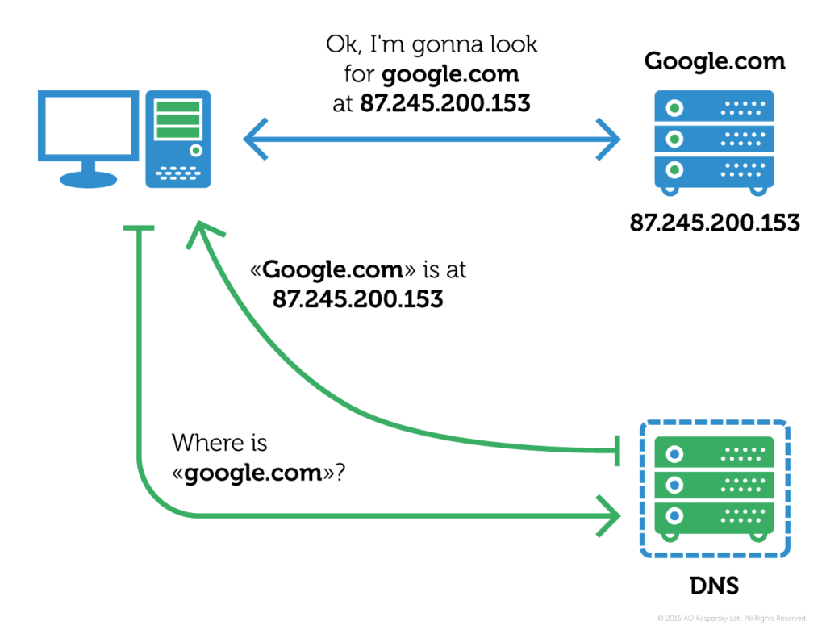

**HTTP Request**

**Get - retrieve data from server**

**Post - change and create data**

**Put - replace the data**

**Delete - delete the data**

**Patch- Patch and update data**

**Get vs Post**

**Restful API(constraints) -Representational State Transfer**

**HTTP status code**

**200- OK**

**300- Moved Permanently**

**400- Authentication vs Authorization**

**500 - Server Internal error**

**Cookies vs Local Storage vs Session Storage**

[**https://wpreset.com/localstorage-sessionstorage-cookies-detailed-comparison/**](https://wpreset.com/localstorage-sessionstorage-cookies-detailed-comparison/)

**Difference: size / expiration date/ accessible from server(communicate between client and server - cookies)**

|  |  |  |  |
| --- | --- | --- | --- |
|  | Cookies | Local Storage | Session Storage |
| Capacity | 4 KB | 5 MB | 5 MB |
| Expiration | Manually Set | Never | On tab close |
| Accessible from server | Yes | No | No |

**Elements Tab - Styles**

**Console - console log**

**Sources - you can find everything that related to front end**

**Minify uglify code**

**HTML - Hypertext Markup Language**

**!DOCTYPE**

**HTML -**

**Head- metadata**

**Body- HTML tags**

SEO - Search Engine Optimization

<https://developers.google.com/search/docs/beginner/seo-starter-guide#descriptionmeta>

Meta tag name= description